**Bhagya Wijeratne - 15219**

**BT 3074 - Practical 04**

1. Derive the best-fitted line analytically for the function $f\left(x_{i}\right)=mx_{i}+b$.

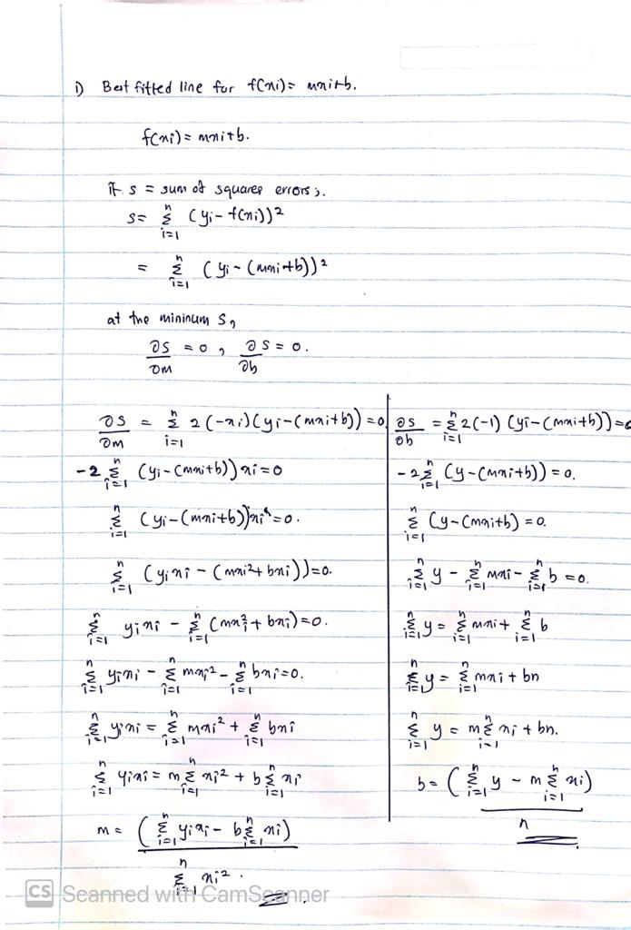



1. Consider a data set with 20 data points that change with time and find the best-fit function for that data set.

Insert your data set.

|  |  |  |  |  |  |  |  |  |  |
| --- | --- | --- | --- | --- | --- | --- | --- | --- | --- |
| t=0 | t=1 | t=2 | t=3 | t=4 | t=5 | t=6 | t=7 | t=8 | t=9 |
| 3 | 4.5 | 5 | 6.5 | 7.9 | 9.8 | 13.3 | 15 | 14 | 15.6 |
| t=10 | t=11 | t=12 | t=13 | t=14 | t=15 | t=16 | t=17 | t=18 | t=19 |
| 18.9 | 18.5 | 20 | 21.5 | 25.1 | 28.5 | 29 | 27.5 | 29 | 32.5 |

Insert the fitted function.

m = $1.5568$, b = $2.4657$

$$f\left(x_{i}\right)=1.5568x_{i}+2.4657$$

Insert the figure with data set and the fitted function.

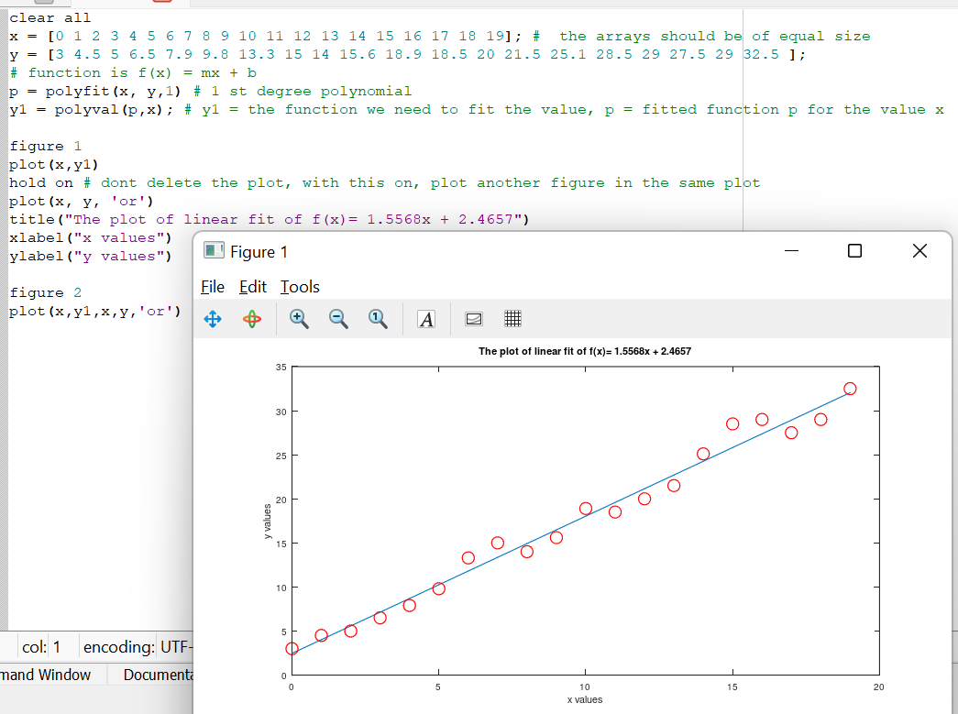

From Lecture 4 code:

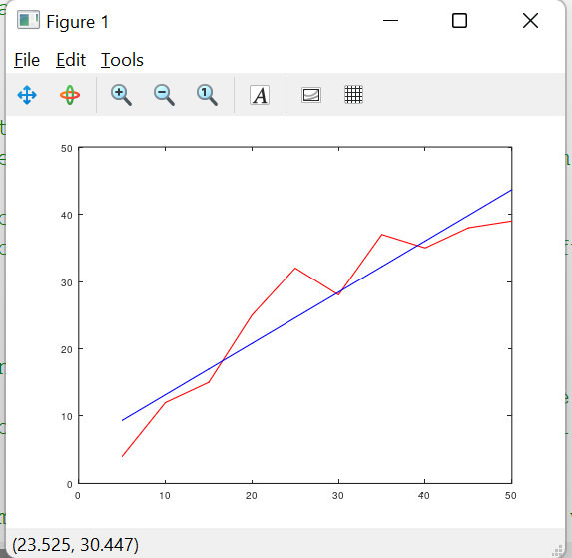

Red line – set of random numbers

Blue line – poly fitted function ( degree 1)and the evaluated y values according to the co efficients

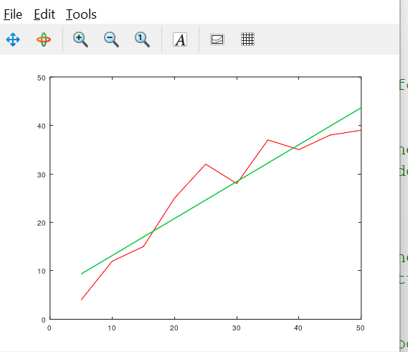

The first degree polynomial overlaps with the other degree polynomials